CHECK OUT SAN ANTONIO

San Antonio is so much more than the Alamo. While there’s plenty of colonial history to explore, there’s also everything a vibrant, modern city has to offer

(MARKET IMAGE HERE)

Find Deals From These Cities

INSERT FARE GRID FROM / TO Version (if available!)

   
Top Things To Do in San Antonio

When visiting San Antonio, you certainly won’t be at a loss for things to do. With so many great attractions in this city, it can be somewhat challenging to decide which ones to make time for. Below are a few we think you shouldn’t miss.

* Stroll along the San Antonio River Walk - this 2 ½-mile network of walkways along the banks of the San Antonio River consists of an eclectic mix of shops, bars, restaurants and more.
* Enjoy one of the latest Broadway shows, a concert, comedy show or other live performance at the Majestic Theatre, San Antonio’s oldest and largest theatre.
* Spend some time appreciating art when you explore the nearly 30 galleries and shops in the La Villita Historic Arts Village, one of San Antonio’s very first neighborhoods.

Travel Tips and Resources

[Must-Dos in San Antoniohttp://www.tripadvisor.com/Attractions-g60956-Activities-San_Antonio_Texas.html](http://www.tripadvisor.com/Attractions-g60956-Activities-San_Antonio_Texas.html)

[San Antonio Hotelshttp://www.tripadvisor.com/Hotels-g60956-San_Antonio_Texas-Hotels.html](http://www.tripadvisor.com/Hotels-g60956-San_Antonio_Texas-Hotels.html)

[San Antonio Restaurantshttp://www.tripadvisor.com/Restaurants-g60956-San_Antonio_Texas.html](http://www.tripadvisor.com/Restaurants-g60956-San_Antonio_Texas.html)

[San Antonio Shopping Guidehttp://www.hotels.com/articles/ar011912/san-antonio-shopping-guide-where-and-what-to-shop-and-buy](http://www.hotels.com/articles/ar011912/san-antonio-shopping-guide-where-and-what-to-shop-and-buy)

[San Antonio Nightlife and Entertainmenthttp://visitsanantonio.com/english/Explore-San-Antonio/Dining/Nightlife](http://visitsanantonio.com/english/Explore-San-Antonio/Dining/Nightlife)

[San Antonio Travel Tipshttp://travel.usnews.com/San_Antonio_TX/Travel_Tips](http://travel.usnews.com/San_Antonio_TX/Travel_Tips)

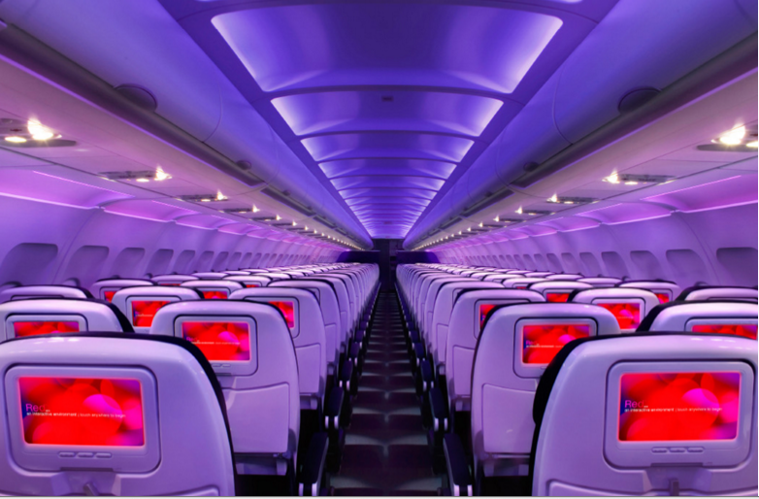

Main Cabin Main Cabin Select First Class

(add links to Cabin Class Pages)

Ready. Set. Fly.

Book your Mood-lit Ride to San Antonio.

If you’re looking at flights to San Antonio, TX, consider spending some time in Austin first and book a flight to Austin with Virgin America. Once you’ve explored Austin, the drive to San Antonio is only about an hour! When you fly with us, you’ll experience pure bliss with our leather seats that were custom-designed to provide maximum comfort and the relaxing and peaceful atmosphere created by our mood-lit cabins. Take a virtual tour to see more of the amazing amenities you’ll be pampered with on our flights.

Take a Virtual Tour

Add Terms & Conditions